**FOOLING EWE, ILLUSTRATED CHILDREN’S BOOK, IS RELEASED**

**FOR IMMEDIATE RELEASE** (Boston, MA – April 1, 2013) – Service Bar Books announces the release of ***Fooling Ewe***.

***Fooling Ewe*** is a beautifully illustrated children’s book about Ewe, a precocious young sheep who's bored grazing all alone. Now Ewe wants to play and play tricks on Chicken, Duck, and even Farmer. A sheep that doesn't follow, Ewe is mischievous but good-natured and the "ewe" versus "you" wordplay in ***Fooling Ewe*** provides a sense of interaction between young readers and the characters that makes it more than fun.

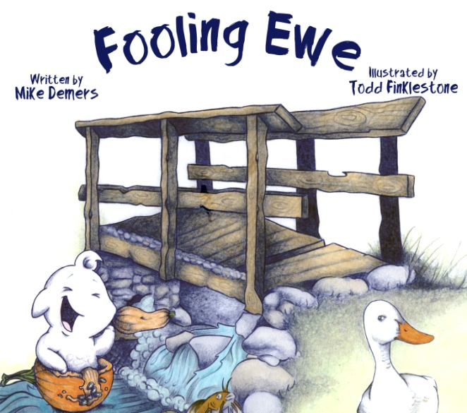

***Fooling Ewe*** is “a great tool for teachers to reinforce the literary significance of homophones and to make homophone learning fun,” describes an educator. “And when learning is fun,” Mike feels “work and play can co-exist and better position the child for success, which leads to better adults, and a better world at a time the world needs to feel better. Ewe is you,” adds the writer. “And Ewe is me” and ***Fooling Ewe*** is the beginning of an exciting foray into children’s literature and social awareness

***Fooling Ewe*** is now available at Amazon.com and in select stores, and free interactive games and learning activities are offered at [www.FoolingEwe.com](http://www.FoolingEwe.com).

**About the Writer**

Mike Demers is a single father three nights a week and tends bar the other four. Leaving behind a promising career in film production, Mike received his MFA in Creative Writing from Emerson College’s graduate program in Boston, Massachusetts before moving to the suburbs for the spoils of family and green grass.

**About the Illustrator**

Todd Finklestone, raised in Framingham, Massachusetts, studied Government and Ethics at Suffolk University. Currently the director of CameroonONE, a Central African NGO that places orphaned children in the households of surviving relatives, Todd is also a first responder for ShelterBox, an organization that offers relief to families made homeless by disasters. ***Fooling Ewe*** is Todd’s first children’s book.

**About Service Bar Books**

Service Bar Books (SBB) is an upstart publishing house with plans to innovate traditional publishing. SBB will offer services to writers and ***Fooling Ewe*** is their debut publication. For more information, visit [www.FoolingEwe.com](http://www.FoolingEwe.com) or email Shaun@FoolingEwe.com.